**Windows 10 UWP – Hands on Lab**

**Lab 3:**

**Note**: The demo app created for this lab uses Visual Studio 2015 with the latest Windows Tools SDK version 10240. To help with our coding efforts with the boiler code and page navigation we use a UWP app extension called Template 10.

1. Open the \ViewModels\ DetailPageViewModel.cs file and add the following lines of code to line 68. Not much code here to add because our recipe service is actually do all the data management for us.

public void SaveBBQRecipe()

  {

      App.RecipeService.Save(recipe);

      ShowMessage("Record has been saved", false);

  }

  public void DeleteBBQRecipe()

  {

      if (!String.IsNullOrEmpty(recipe.Id))

      {

          App.RecipeService.Remove(recipe.Id);

          ShowMessage("Record has been deleted", true);

      }

  }

1. Open the \Views\ DetailPage.xaml file and add the following lines of Xaml code to line 66. This StackPanel will be placed with the DetailsStackPanel.

<StackPanel Margin="0,0,20,10" Orientation="Horizontal" Padding="10" HorizontalAlignment="Center" x:Name="ButtonPanel">

                    <Button  Margin="10" x:Name="ButtonSave" Content="Save" FontSize="32"  Click="{x:Bind ViewModel.SaveBBQRecipe}">

                        <Button.Background>

                            <LinearGradientBrush EndPoint="0.5,1" StartPoint="0.5,0">

                                <GradientStop Color="#FF6ACD18" Offset="0.171"/>

                                <GradientStop Color="#FF0A0A0A"/>

                                <GradientStop Color="#FF0A0A0A" Offset="0.98"/>

                                <GradientStop Color="#FF6ACD18" Offset="0.949"/>

                            </LinearGradientBrush>

                        </Button.Background>

                    </Button>

                    <Button Margin="10" x:Name="ButtonDelete" Content="Delete" FontSize="32" Click="{x:Bind ViewModel.DeleteBBQRecipe}">

                        <Button.Background>

                            <LinearGradientBrush EndPoint="0.5,1" StartPoint="0.5,0">

                                <GradientStop Color="#FFCD1D18" Offset="0.171"/>

                                <GradientStop Color="#FF0A0A0A"/>

                                <GradientStop Color="#FF0A0A0A" Offset="0.98"/>

                                <GradientStop Color="#FFCD1D18" Offset="0.949"/>

                            </LinearGradientBrush>

                        </Button.Background>

                    </Button>

                </StackPanel>

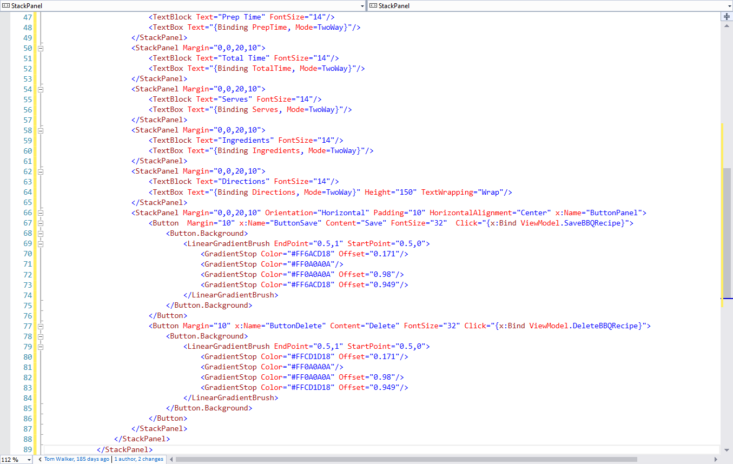

1. We need add a minor tweak to the DetailPage’s UI in order to see the buttons from step 2. For this step we need to wrap the BBQRecipeGridView contents insider a ScrollViewer Xaml control. To help with this work we need to collapse the StackPanel contents that we just added in step 2. Next we will wrap the StackPanel control within a ScrollViewer control.

